Lab 09b - Implement Azure Container Instances

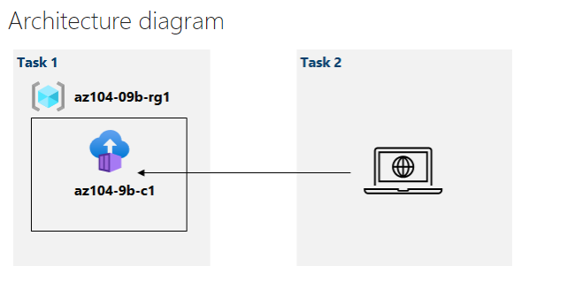

* Task 1: Deploy a Docker image by using the Azure Container Instance.
  + In this task, we will create a new container instance for the web application.

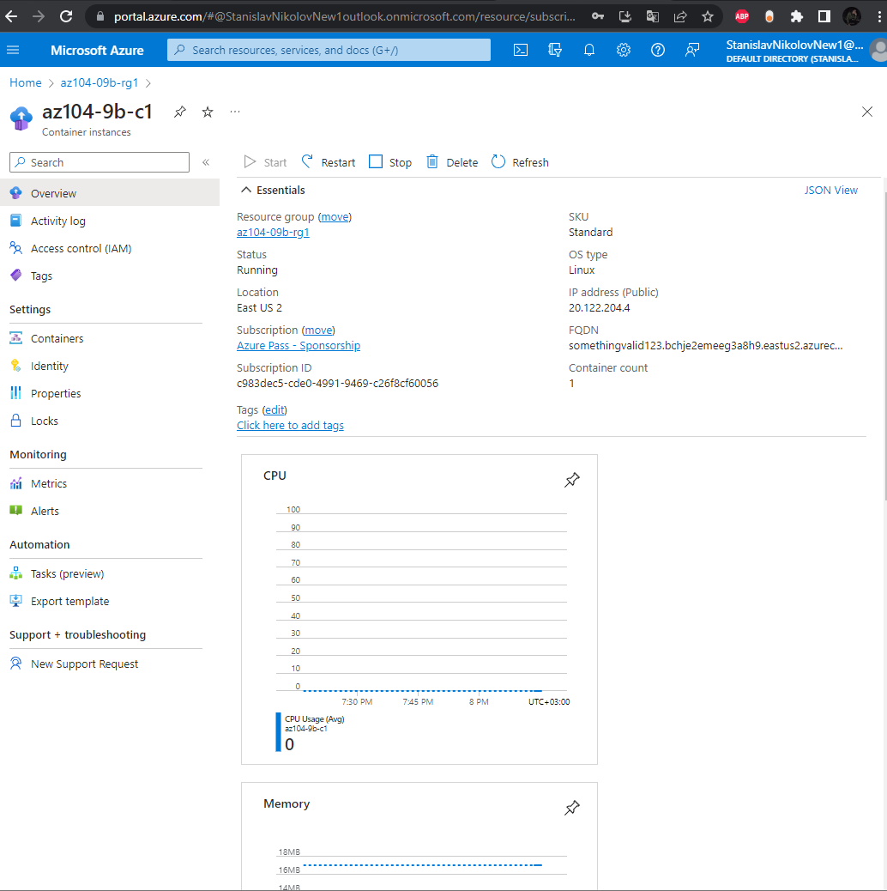

* Task 2: Review the functionality of the Azure Container Instance.
  + In this task, we will review the deployment of the container instance.

FQDN: somethingvalid123.bchje2emeeg3a8h9.eastus2.azurecontainer.io

* + Verifying that you see the log entries representing the HTTP GET request generated by displaying the application in the browser.

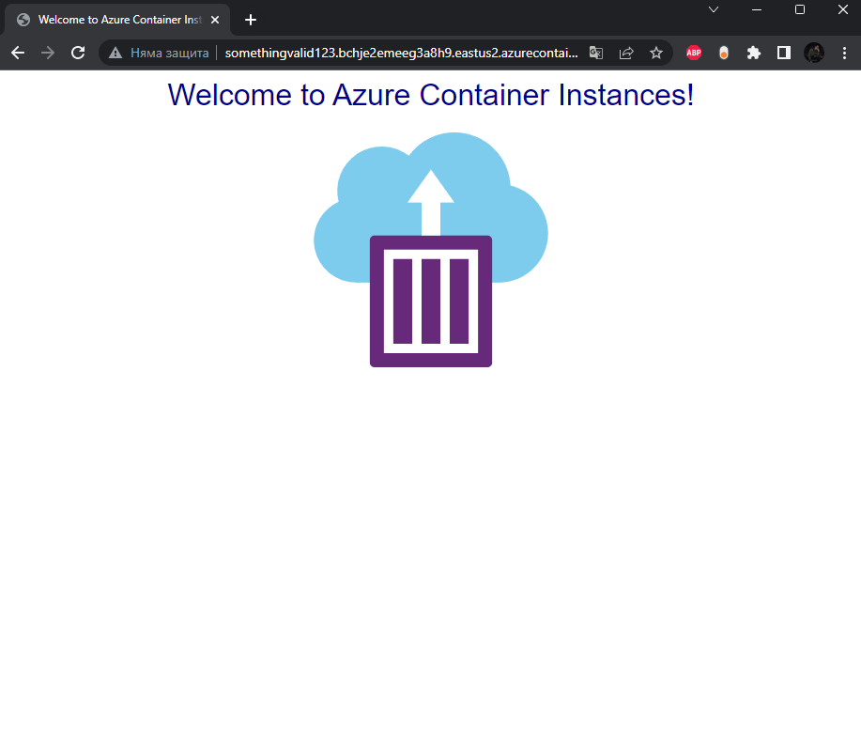

* + Verifying that we see the log entries representing the HTTP GET request generated by displaying the application in the browser.

